**TABLE: PRODUCT**

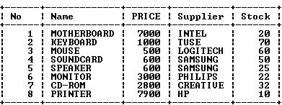

**QUERIES:**

1. Display data for the entire item sorted by their name.
2. Display the Name and Price from the table item in reverse order of their stock.
3. List all Name and Price between 3000 and 7000.
4. Write the command to set the price field of all products to 1200 corresponding to

Name=”keyboard”.

1. Write the SQL command to delete rows with stock between 20 to 40.
2. To count the number of products with stock <5.
3. Give the output of the following SQL command:
4. Select SUM(stock) from PRODUCT;
5. Select AVG(Stock) from PRODUCT where stock >20;
6. Select COUNT(DISTINCT stock) from PRODUCT;
7. Select MAX(Price) from PRODUCT;

A.

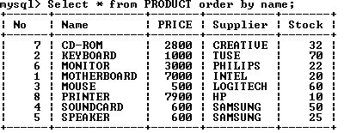

**B**

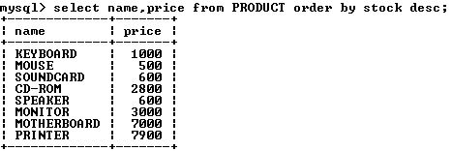

C

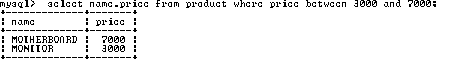

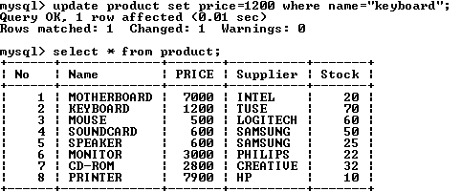D

E

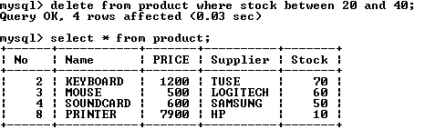

F

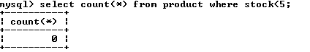

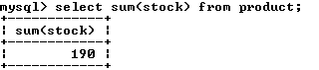G.

i)

ii) 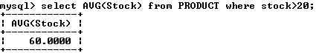

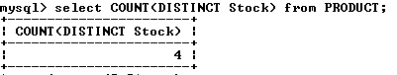iii)

iv) 